MODULE: CS4001 PROGRAMMING
Assignment: Coursework 003

GADAF MALIK-ABBAS
Student ID: 25000098
Submission Date: 21st April 2026

Gadget Shop Management System

Table of Contents
1. Introduction 3
2. GitHub Repository Link 3
3. System Design Overview 4
3.1 Core Device Classes 4
3.2 Application Control Class (GadgetShop) 4
3.3 Object-Oriented Principles. 5
3.4 Design Evaluation. 5
4. UML Class Diagram 5
5. Classes and Methods Description 8
6. Pseudocode for Button Handling Methods 10
6.1 Get Display Number 10
6.2 Add Mobile 10
6.3 Adding an MP3 11
6.4 Displaying All Gadgets 11
6.5 Making a Call 12
6.6 Downloading Music 13
6.7 Clear Fields 14
6.8 Deleting Music 14
7. Input Validation and Textboxes 14
7.1 Textbox Inputs. 15
7.2 Logical Validation. 16
7.3 User Feedback. 16
8. Buttons and Action Methods 17
8.1 Button Functionality 21
8.2 Other Button Actions 21
8.3 Event Handling Method 22
8.4 Design Reflection 22
9. Graphical User Interface 22
10. Testing and Screenshots 23
11. Running Program in Command Prompt 29
12. Error Detection and Correction 32
13. Additional Features Addition 34
14. Conclusion 35
15. References 35
16. Appendix 36
Appendix A – Gadget 36
Appendix B – Mobile 38
Appendix C – MP3 41
Appendix D – GadgetShop 44

1. Introduction
The current project outlines the design and implementation of a Gadget Shop Management System that was developed in Java and was presented using the JavaFX-based graphical user interface. It features the ability for interaction with one’s electronic environment, including mobile phones and MP3 players. The application exemplifies the main tenets of OOP like encapsulation, inheritance, polymorphism, method overriding and so forth [1]. These ideas enable the system to be organised in an effective manner and support modular and reusable code generation. The system is made up of four types of classes:
• Gadget – the class holding the attributes that are the same in all of the devices.
• Mobile – a subclass for phones, it calls the app, too.
• MP3 – music device subclass with memory management.
• GadgetShop – the main class responsible for handling the graphical interface and user interactions.
The application enables users to perform major operations, such as:
- Add Mobile phones
- Add MP3 players
- Display stored gadgets
- Make phone calls
- Download music
- Delete Music
- Handle invalid input by validating and failing to return valid results
To further increase user interface efficiency, a JavaFX based graphical interface: button-entry boxes plus text fields and dialog boxes are provided in JavaFX. Interface functions [2].

2. GitHub Repository Link
This project is hosted on GitHub for good version control, backup, and accessibility. GitHub provides a place for developers to track modifications, to work together in a smooth manner, and to keep track of the project's evolution history [7]. It is commonly used in industry for managing software projects and improving software development reliability [2].
The entire source code of this project is on GitHub. GitHub Repository: gam0416/Gadaf-Gadget-Shop-Project: Gadget Shop project for MP3 and Mobile inventory app
The following classes are contained in the repository:
- Gadget.java
- Mobile.java
- MP3.java
- GadgetShop.java
Fig 1 below: GitHub Repository Showing Project Files.
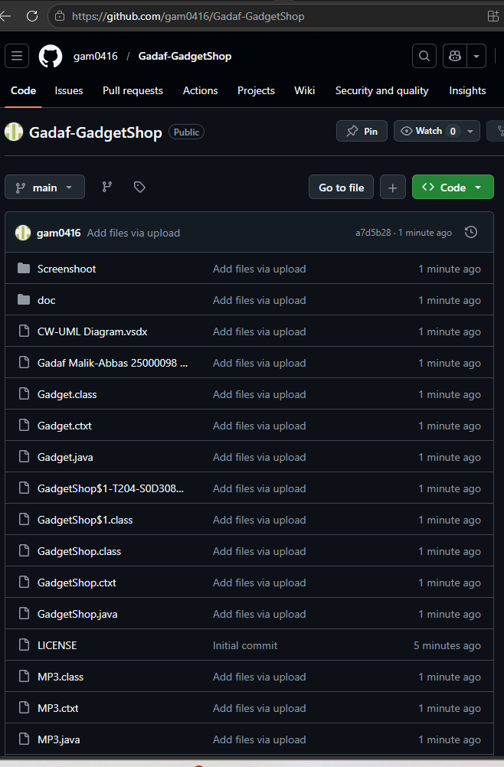

3. System Design Overview
The system has been designed using layers with an object-oriented approach, where each class is assigned clear responsibilities [1], [4]. This strategy contributes to maintaining the codebase and helps maintain a clear separation between business-related logic and user interactions [1].
A UML class diagram was also prepared in advance of the project to assist the design step. Class diagrams are common for object-oriented system design, as they help to convey the structure of the system, containing classes, attributes, methods, and the relationships between them [6]. It helps in diagnosing design problems early, like a lack of relations or duplicate information [1].
The BlueJ UML class diagram of the Gadget Shop system is illustrated in Fig 2 below:
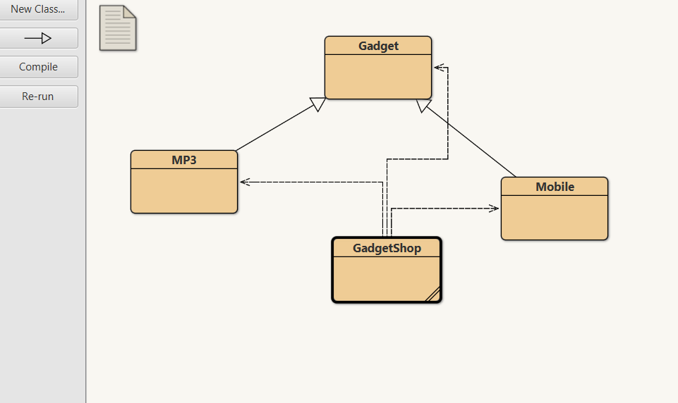

3.1 Core Device Classes
The core device classes represent the actual electronic devices in the system:
- Gadget (superclass)
- Mobile (subclass)
- MP3 (subclass)
The Gadget class defines common attributes such as model, price, weight, and size. It also includes a constructor and a display() method to output device details.
The Mobile and MP3 classes inherit from the Gadget class, allowing them to reuse existing functionality while introducing specialised behaviour. This relationship is illustrated in the UML diagram and demonstrates inheritance in practice [1].
The Mobile class extends functionality by adding calling credit and a makeCall() method, which simulates phone calls and deducts credit.
The MP3 class extends functionality by managing available memory and implementing a downloadMusic() method. An additional feature was introduced where a 3GB SD card is automatically added when memory is insufficient. This enhancement improves usability and demonstrates extended logic beyond the basic requirements.

3.2 Application Control Class (GadgetShop)
The GadgetShop class acts as the central control unit of the system. It manages user interaction through the JavaFX GUI and performs the following tasks:
- Collects user input from text fields
- Creates device objects
- Stores objects in an ArrayList<Gadget>
- Executes operations such as calls and downloads
The use of ArrayList<Gadget> enables polymorphism, allowing different object types (Mobile and MP3) to be handled using a single reference type [1]. This makes the system flexible and easy to extend.

3.3 Object-Oriented Principles.
The system illustrates a few principles of object-oriented programming (OOP):
Encapsulation: Each of your classes contain data and have its own way of working, so internal knowledge is embedded there and only viewed at interfaces.
Inheritance: The Mobile and MP3 classes are built upon Gadget class. This way, the code can be reused and there are no repeats.
Polymorphism: The use of `ArrayList<Gadget>` facilitates both processing a set of different object types in the same manner while allowing us to represent them in their own manner.
Method Overriding: They have both the `display()` and method (actually overridden) in their Mobile and MP3 classes as well for custom output.
The relationships and inheritances of the classes, as well as the method design are nicely presented in the UML class diagram. .

3.4 Design Evaluation.
The chosen design does a nice job of separating business logic (device behaviour) and user interface (GUI). That makes the separation good for maintainability between, Interface does not change interface, Interface supports code base and vice versa. The system is actually extensible. As such, you can easily add new types of devices like Tablet or Smartwatch by augmenting the Gadget class and making nothing on the structure. These other features, such as automatic SD card memory upgrade, etc.

4. UML Class Diagram
A UML Class diagram is a very important part of object-oriented design, which is important to give a transparent visual of a static structure of the system: classes, attributes, methods and relationships [6]. In a word, they are the body of your program and help to shine light into design problems right away, to identify redundancy, incorrect methods and wrong class relations [6].
Gadget is the parent class (superclass) that holds all the features of the gadgets, such as the gadget types, the gadget data structure and the gadgets methods. These are model, price, weight, size and constructor, accessor methods and display method. These Mobile and MP3 classes are your child classes or subclasses that inherit the common code of Gadget to create their own unique attributes/methods [1].
Therefore, the Mobile class adds calling credit and methods like make a call, the MP3 class adds available memory and methods like downloading/deleting music. This is described in the class diagram as the solid line and arrowhead from the Mobile and MP3 classes towards the Gadget class [6].
The GadgetShop class is distinct from the Mobile, MP3 or Gadget classes. It also does not have to be a piece of hardware in and of itself. GadgetShop does not exist in an inheritance topology; it’s part of the system, bringing the classes together so that the program is the same system [4].

Fig 3 below shows the UML diagram for the Gadgetshop project:
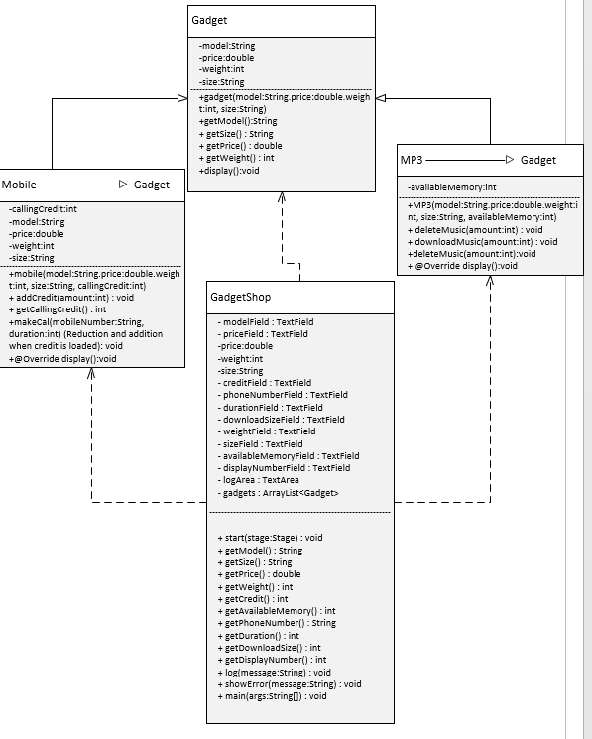
Mobile and MP3 inherit similar attributes from the Gadget class. Both subclasses are polymorphic, that is, they take the display() method and override it.

5. Classes and Methods Description
Gadget Class
Gadget class is a general electronic device, and this is the superclass of all electronic devices. It possesses every one of the ordinary-cycling behaviours observed in gadgets [1].
Attributes:
- Model: the name of the model of the gadget.
- price: is the cost of the gadget.
- weight: holds the appliance footprint.
- size: stores the physical size of a device.
Methods:
Constructor (String model, double price, int weight, String size)
It is used to generate an object generation initial properties from the constructor. Like: model, price, weight, size, return type is also void [10].
- getModel()
The point is to have returned the model of a saved gadget. The type of return is String that does not contain any parameters.
- getPrice()
That’s to return the cost of the gadget. No parameters, the type double returned.
- getWeight()
The intention is to send back the weight of the gadget. No parameters, return type integer.
- getSize()
It returns the size of the gadget. No parameters are specified and the return type is String.
- display()
The purpose is to show all the main characteristics of the gadget: model, cost, weight and size. Parameters are missing and the type of return is void.
Mobile class
Is the Gadget class extend for mobile phone, it is where I actually build and customize it. It inherits every portable phone feature along with mobile-focused features [1].
Additional Attribute:
callingCredit: Today's Call Credit is calling in minutes.
Methods:
Constructor (String model, double price, int weight, String size, int credit)
This constructor is for configuring all the inherited gadget properties and mobile-specific calling credit. It has no type of return, and all the values are in the form of parameters.
- addCredit(int amount)
This means adding something to the call credit. The value is the number of minutes I have to add, and the return type does not apply.
- makeCall(String number, int duration)
This is so I can simulate making a call via phone. It removes the time of scheduled credit when enough credit is available. Parameters used: phone (String) and duration of call (int), return type is void.
- display()
This method takes advantage of the display method of the Gadget class and includes some metadata for mobiles, such as credit remaining. It has no parameters, and the return type is void.
MP3 Class
MP3 builds on Gadget for a music player device. It accepts the elementary gadget properties and memory administration [1].
Additional Attribute:
availableMemory: contains the space available in MB.
Methods:
Constructor (String model, double price, int weight, String size, int memory)
This constructor produces MP3 objects with inherited gadget attributes (as well as memory). All variables must be parameters and return type void.
- downloadMusic(int amount)
Execute music downloads when the user can spare memory. If there is not enough memory, it sends a 3GB SD card (3048 MB) automatically to the memory and retries the download. It is worth MB, and the return type depends on the size of the music file.
- deleteMusic(int amount)
The reason that music can be deleted is to expand the area and memory along with it. The parameter is the amount of memory is restored, and there is a void return type.
- display()
This command overrides Gadget display and simply adds things according to memory. It just doesn’t have any parameters, and the return type is void [10].

6. Pseudocode for Button Handling Methods

6.1 Get Display Number
Method: getDisplayNumber
BEGIN
SET displayNumber = -1
TRY
READ value from displayNumberField
CONVERT value to integer
IF displayNumber < 0 OR displayNumber >= gadgets.size THEN
DISPLAY error message
RETURN -1
ENDIF
RETURN displayNumber
CATCH error
DISPLAY "Display number must be a whole number"
RETURN -1
END

6.2 Add Mobile
Method: onAddMobileButtonClick
BEGIN
TRY
READ model, size, price, weight, credit
IF model is empty OR size is empty THEN
DISPLAY error message
EXIT
ENDIF
CREATE Mobile object
ADD Mobile to gadgets list
DISPLAY "Mobile added successfully"
CATCH input error
DISPLAY error message
END

6.3 Adding an MP3
Method: onAddMP3ButtonClick
BEGIN
TRY
READ model, size, price, weight, availableMemory
IF model is empty OR size is empty THEN
DISPLAY error message
EXIT
ENDIF
CREATE MP3 object
ADD MP3 to gadgets list
DISPLAY "MP3 added successfully"
CATCH input error
DISPLAY error message
END

6.4 Displaying All Gadgets
Method: onDisplayAllButtonClick
BEGIN
IF gadgets list is empty THEN
DISPLAY "No gadgets to display"
EXIT
ENDIF
FOR each gadget in gadgets list
DISPLAY index number
CALL display() method
ENDFOR
DISPLAY "All gadgets displayed"
END

6.5 Making a Call
Method: onMakeCallButtonClick
BEGIN
SET displayNumber = getDisplayNumber()
IF displayNumber = -1 THEN
EXIT
ENDIF
GET gadget at displayNumber
IF gadget is Mobile THEN
READ phoneNumber (String)
READ duration
CALL makeCall(phoneNumber, duration)
DISPLAY "Call completed"
ELSE
DISPLAY error "Selected gadget is not a Mobile"
ENDIF
END

6.6 Downloading Music
Method: onDownloadMusicButtonClick
BEGIN
SET displayNumber = getDisplayNumber()
IF displayNumber = -1 THEN
EXIT
ENDIF
GET gadget at displayNumber
IF gadget is MP3 THEN
READ downloadSize
IF availableMemory >= downloadSize THEN
REDUCE memory
DISPLAY "Music downloaded successfully"
ELSE
DISPLAY "Not enough memory"
DISPLAY "Add 2G SD card"
ADD 2048MB to memory
DISPLAY "SD card added successfully"
IF memory >= downloadSize THEN
REDUCE memory
DISPLAY "Download successful after upgrade"
ENDIF
ENDIF
ELSE
DISPLAY error "Selected gadget is not an MP3"
ENDIF
END

6.7 Clear Fields
Method: onClearButtonClick
BEGIN
CLEAR all input fields
DISPLAY "All fields cleared"
END

6.8 Deleting Music
Method: onDeleteMusicButtonClick
BEGIN
Read displayNumber
IF displayNumber is valid AND gadget is MP3 THEN
Read deleteSize
Call deleteMusic(deleteSize)
Display updated memory
ELSE
Show error message
END

7. Input Validation and Textboxes
The GUI of the system was designed based using JavaFX components to ensure clean, intuitive, and user-friendly design [2]. In addition, relationships between input and output are addressed with respect to TextFields, labels, buttons and TextArea for user inputs and real-time system feedback. In this regard, input validation makes it possible to provide correct and useful data. If the data type or value is invalid and it is not well validated, the program "will break down" or have unusual behaviour [5].
In this system, the input to various TextField segments is price, weight, memory size, call duration, display number, etc. Validation is implemented by using try-catch blocks, as these values should be numeric to avoid runtime issues [2], [8].
Fig 4 below illustrates Display Number Input Validation Using try-catch with Range Checking and Error Handling.
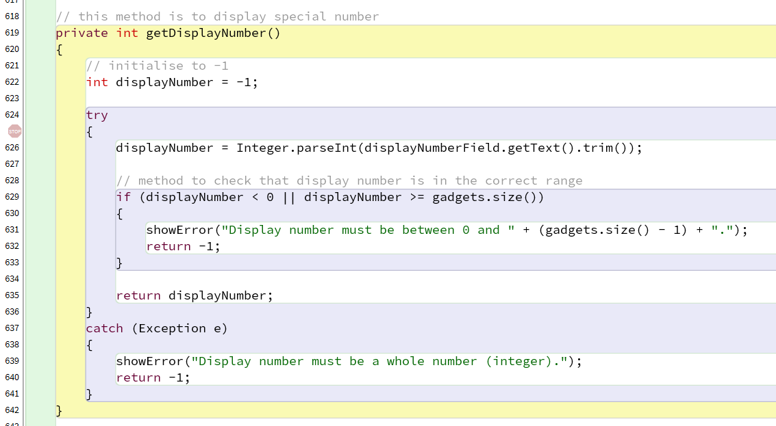
If the data users enter values on the table where the system cannot identify values, the system catches an error (e.g., text instead of a number, or entering a JavaFX Alert dialogue box) and issues an error message. This acts to keep the application running in the same way as intended and prevents it from crashing [3].
Together with basic validation, logical validation checks are constructed for higher system reliability as well. These include:
- Ensuring that the right information (Model, size, etc.) is not missing.
- Validate that the display number is in the ArrayList range.
- Make sure the download and delete sizes are bigger than zero.
- Ensure actions are executed only under the right kind of object (e.g. Mobile or MP3) [1].
User feedback is included as Alert dialog boxes as well as in a TextArea log area reporting system responses and actions. This improves the design usability and the ability to see with a clear eye the product of a user’s actions.
Overall, the process of validating the system not only adds to both the system’s sturdiness and reliability but also makes it easy for the user to use by stopping an invalid operation in its tracks and safely running the programs [3], [5].

7.1 Textbox Inputs.
I use a few TextField components to create the input to be given to the user which are:
- Model.
- Price (£).
- Weight (g).
- Size (mm).
- Available Memory (MB).
- Initial Credit (mins).
- Phone Number (String format to match UK phone number format).
- Call Duration (mins).
- Download Size (MB).
- Delete Music (MB).
- Display Number (index).
One textbox contains the matching data that, in a computer language, at least usable user input can be input, and no mistakes are committed by the system during the input. The second and paramount one is input validation, the system checks how accurately data is presented and checks the system operating time errors when running in general operation and execution process. Since I have to get the numbers of all the fields to turn it into multiple fields, I used try/catch blocks when working with the input to change the raw value of the string into an int and make it double, etc.
For example, in the fig 5 below, we can visualise how the input was validated by using try/catch for the numeric field conversion of input as weight:
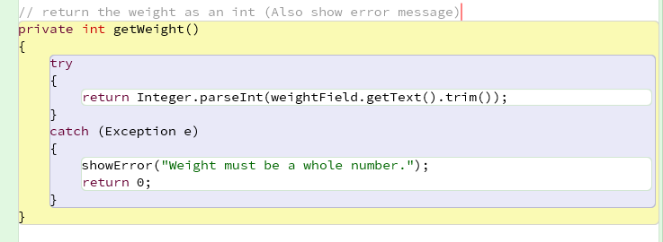
This means that the program should not crash if a user entered a data that is invalid (sent data in text and not numbers). Instead, it should display a clear, useful error message. .

7.2 Logical Validation.
Besides using simple kind validation, the system uses logical validation checks.
Check model & size fields are not empty as the device design is occurring.
To check the display number is within the valid range of ArrayList.
Making sure that category of digital gadget coincides with activity-mixed (e.g. only Mobile does call and only MP3 does music). If there are faults, they are avoided and the system becomes more reliable. .

7.3 User Feedback.
In order to improve the user experience, the system implement JavaFX Alert dialogue boxes allowing:
- Error messages if the input is wrong.
- When wrong actions are tried, guidance messages.
Further, TextArea (logArea) are set up on display to display in real-time the system response to the call, which the outputs of functions such as display(), makeCall() and downloadMusic() give out. In general, the fact that it contains structured text box input processing, input validation functions and methods to collect user feedback leads the system to be both robust and user-friendly. Most importantly, try-catch blocks, range checking, and errors are all Ill in place so I can minimize the chance that invalid input is generated, and make the app more accessible and user-friendly so it is easy to use for everyone.

8. Buttons and Action Methods
There are several buttons in this graphical user interface which allow a user to do all kinds of operations in the system. The button itself is connected to an event handler using the JavaFX method setOnAction(e -> { ... }), which specifies the operations executed when the button is clicked [2], [8]. Using event-driven programming, the system is able to manage user actions efficiently by grouping any logic into different handlers to enhance code readability [4].
Button Overview Table
Button | Function
Add Mobile | Creates a Mobile object
Add MP3 | Creates an MP3 object
Display All | Displays all stored gadgets
Make A Call | Executes a phone call
Download Music | Downloads music
Clear | Resets all input fields
Delete Music | Delete Music and update available memory
The buttons are executed separately, thus the code is easier to read, debug and maintain. This is stronger than a single event handler method [2].
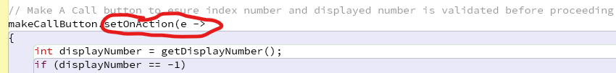
Fig 6: Text Fields and Data Storage Setup 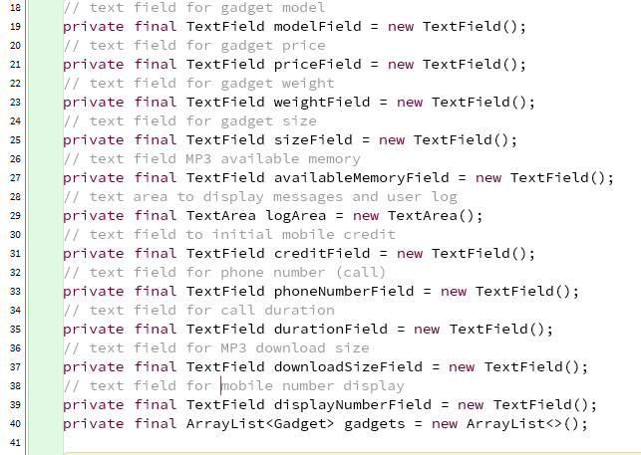
The system presents all necessary text fields to form the user input and also the `ArrayList<Gadget>` which is a list of objects created by the system. To this form of device, encoding makes the same kind of gadget manageable.
Fig7: Add Mobile Button Implementation
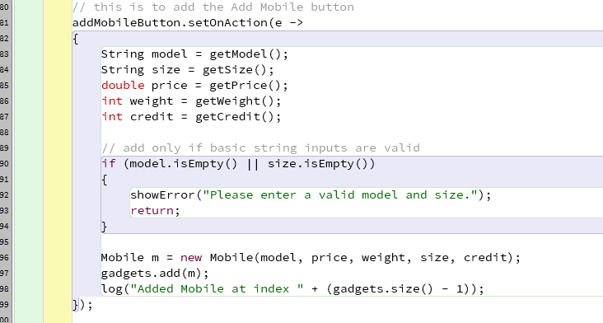
Here is an image of the “Add Mobile” button that takes up the input value, accepts them, validates it, creates a Mobile object, and saves it in the ArrayList.

Fig 8: Add MP3 Button Implementation
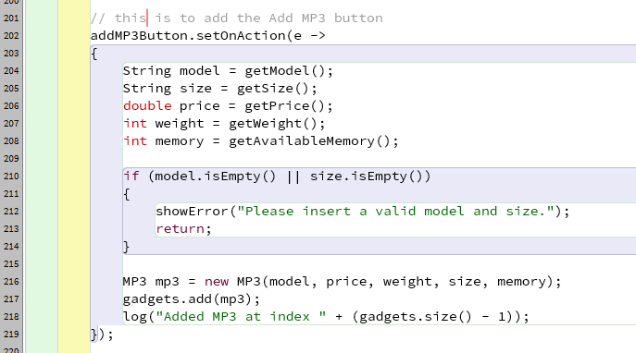
The “Add MP3” button implemented in this figure illustrates how memory input is collected, validated, and fed into the memory structure of the device to build a new MP3 object.
Fig 9: Display All Button Logic
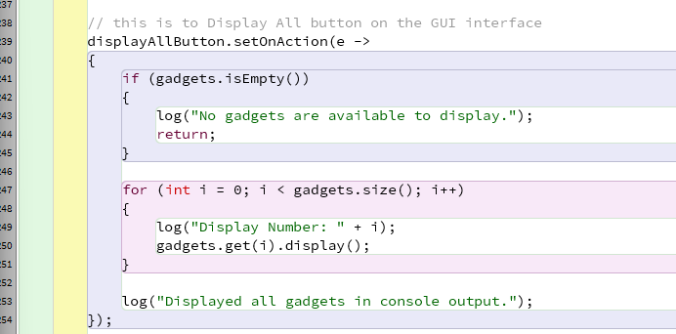
This is looping the system through the ArrayList, which calls the `display()` method on each gadget to make sure that all of the information will be displayed.

Fig 10: Make A Call Button with Type Checking
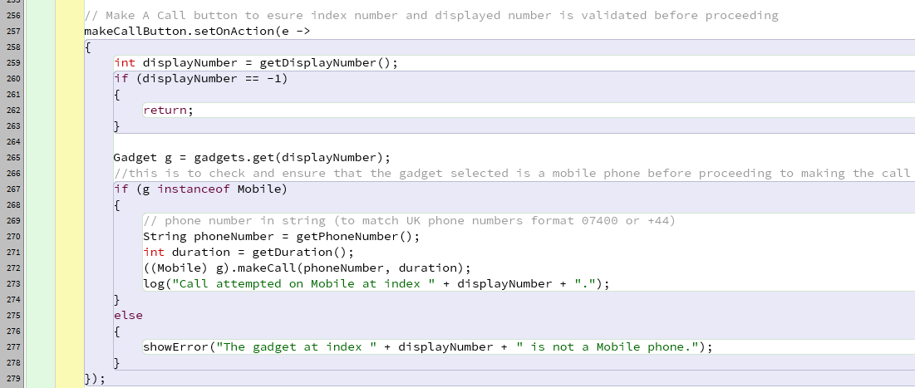
This figure illustrates how the system retrieves a chosen gadget index, validates it and checks if the object (using `instanceof`) is a Mobile before calling.
Fig 11: Download Music Button with Safe Casting
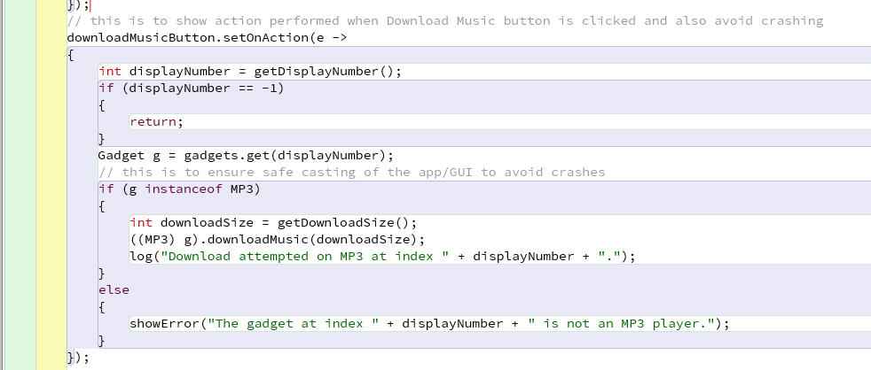
This is how the MP3 takes precedence over the other devices in the system when selecting what gadget to download ahead of a song.

Fig 12: 2G SD card Automatic update logic
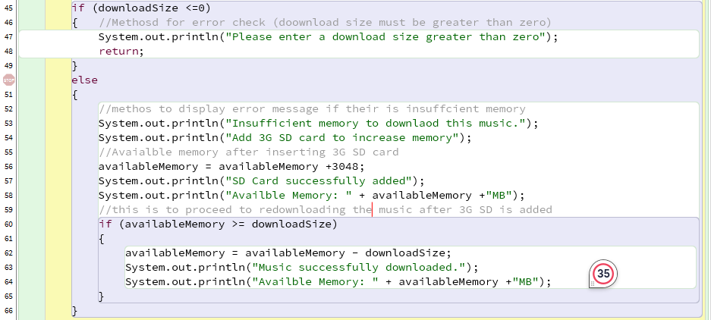
This added bonus is that when the memory capacity is too small to download music, the system will auto-add a 3GB SD card and automatically proceed to downloading the music.

8.1 Button Functionality
After the button is pressed, the system runs a series of actions according to what this system needs to accomplish. For example, if the “Add Mobile” button is pressed:
- The system reads the input values from (model, price, weight, size, credit) in text fields.
- Values are validated using input validation methods like try-catch blocks.
- Generate a new Mobile object with the data given.
- This item is added to the `ArrayList<Gadget>`.
- A confirmation message pops up in the log space.
The “Add MP3” button goes through a similar process.

8.2 Other Button Actions
- Display All button continues through the ArrayList and invokes the `display()` method to call each gadget.
- Make A Call button checks the selected gadget for Mobile gadgets using `instanceof`, and invokes the `makeCall()` method.
- Download Music button asserts whether a piece of equipment selected is an MP3 and triggers the `downloadMusic()` method. When there is not enough memory, the feature on the program will auto-add a 2GB SD card.
- Clear button resets every single one of the input fields for new data.
- Delete Music button checks whether the selected gadget is an MP3 object and calls the deleteMusic() method. This increases the available memory after removing selected music files. The updated memory is displayed in the log area, ensuring the user can see the result immediately.

8.3 Event Handling Method
Each button has a separate setOnAction() code that makes sure that:
- Actions are treated independently.
- Code is simpler to read and debug.
- Less redundancy than simply relying on one large method.
Conditional checks like if (g instanceof Mobile) is incorporated to ensure the correct operation is conducted on the correct object type. This avoids runtime error cases and enhances system robustness as shown in fig 10 below:
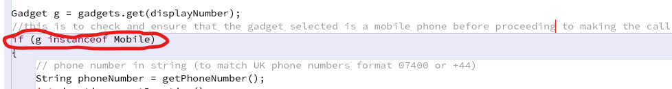

8.4 Design Reflection
The organized button handling guarantees that user actions are responded to in an understandable and predictable manner. This makes any operations easier to maintain and extend with the system as well by partitioning operations into individual event handlers. This implementation improves functionality and simplicity of the application using the validation and type checking capabilities as well since the application performs only valid work.

9. Graphical User Interface
The graphical interface was created with JavaFX components, such as:
- Labels
- TextFields
- Buttons
- TextArea
- Alert dialogues
This design permits users to easily input gadget information to perform the required operations.
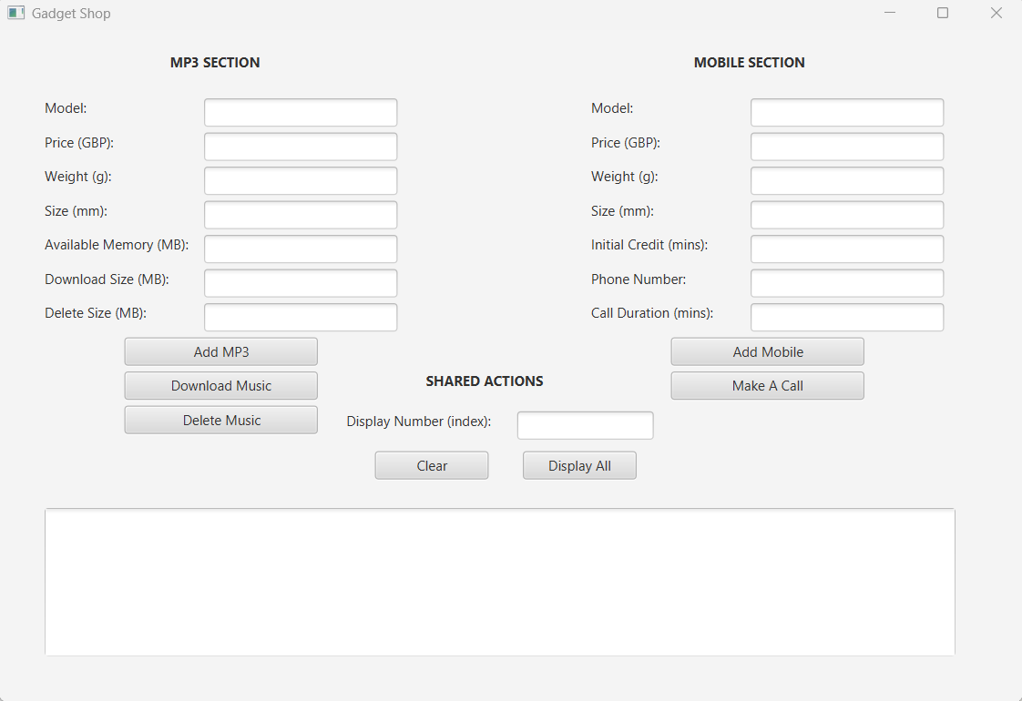
Fig 13: Graphical User Interface of the Gadget Shop app above.
The system design follows reusable object-oriented principles similar to design patterns used in software engineering [9]. This approach improves code reusability, maintainability, and scalability by ensuring that classes are structured logically and responsibilities are clearly defined

10. Testing and Screenshots
Test 1 – Adding a Mobile
- Model: iPhone 14 Pro Max
- Price: 970
- Weight: 250
- Size: 70x80x40
- Initial Credit: 60
Expected Result: The screenshot below shows mobile phone information entered correctly in the text field and “Add mobile” button was pressed. Confirmation of the mobile phone details entered the system is reflected I the text box.
Mobile object added successfully.
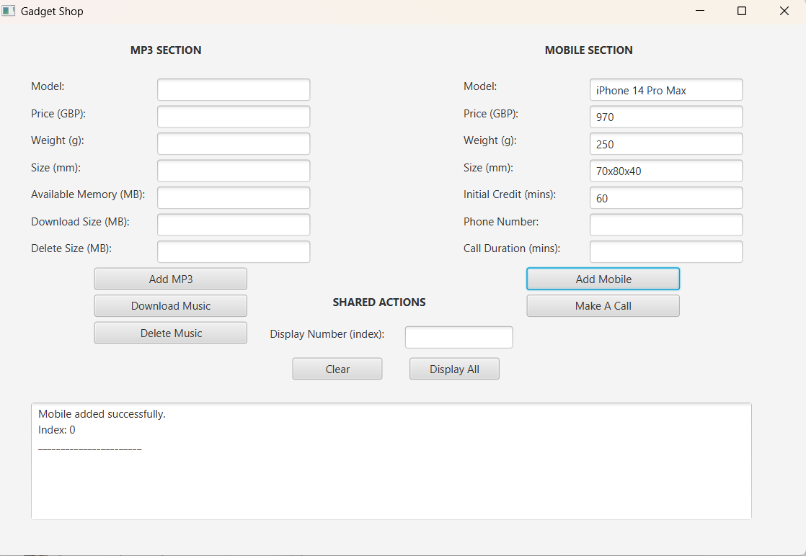
Test 2: Adding an MP3 Player
- Model: Sony Walkman 2013
- Price: 90
- Weight: 50
- Size: 30x20x10
- Memory: 2000 MB
Expected Result: The screenshot below shows Sony Walkman MP3 information entered correctly in the text field and “Add MP3” button was pressed. Confirmation of the MP3 details entered the system is reflected I the text box.
MP3 player added successfully.
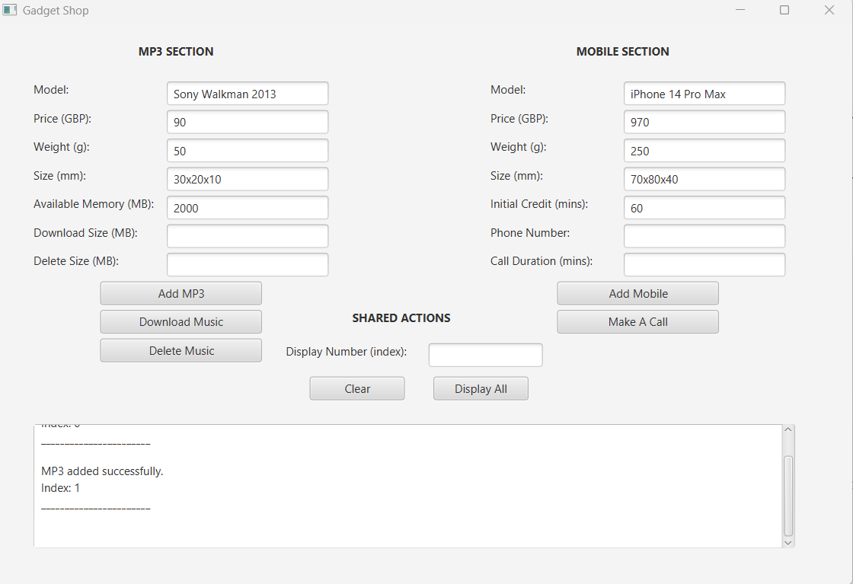
Test 3: Displaying All Gadgets
Press Display All .
Expected Result: The screenshot below shows the display of all the gadgets added on to the system in the textbox as highlighted.
All gadgets displayed successfully.
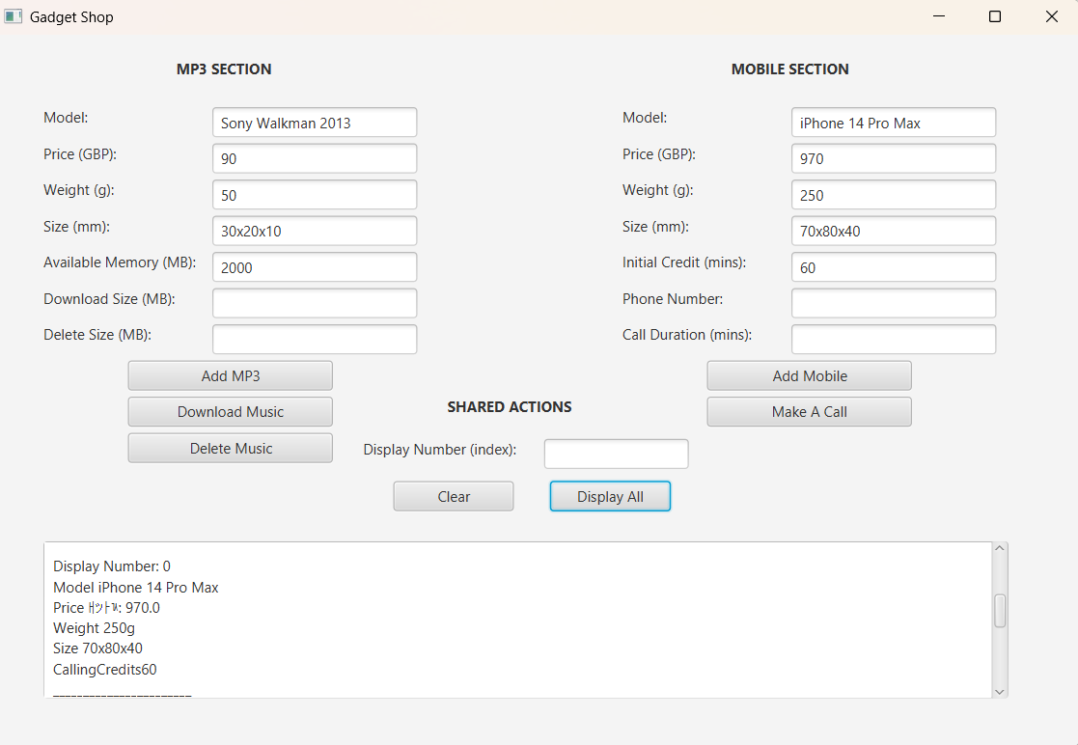
Test 4 – Making a Call
Enter phone number and duration.
Expected Result: The screenshot below shows decreases of calling minutes to 40 mins once the mobile number and the call duration of 20 mins was entered and “Make A Call” button was pressed. Credit decreases successfully.
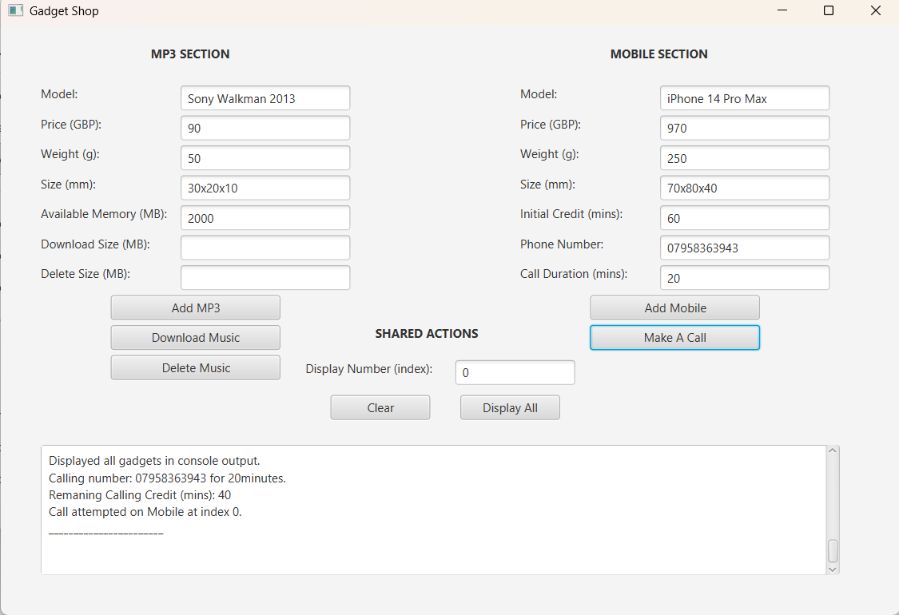
Test 5 – Downloading Music
500MB music size was entered for download.
Expected Result: The screenshot below shows a decrease in available memory to 1500MB from 2000MB when a music size of 500MB is entered and the “Download Music” button is pressed.
MP3 available memory decreases successfully.
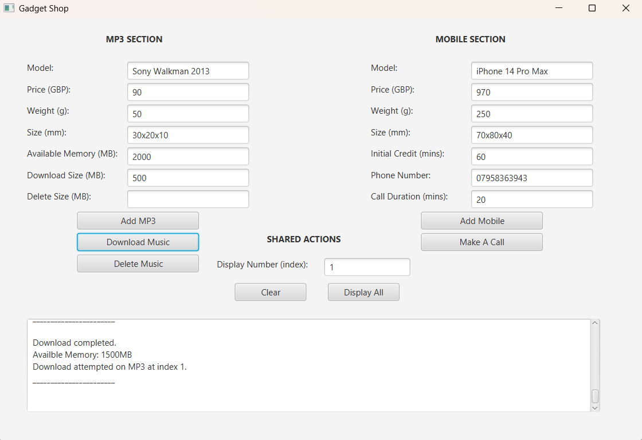
Test 6 – Invalid Display Number
An incorrect index of “1” is entered instead of “0”.
Expected Result: The screenshot below shows an error message informing me that I should have entered Zero (0) instead of one (1) when I pressed the “Download Music” button.
Error message displayed successfully.
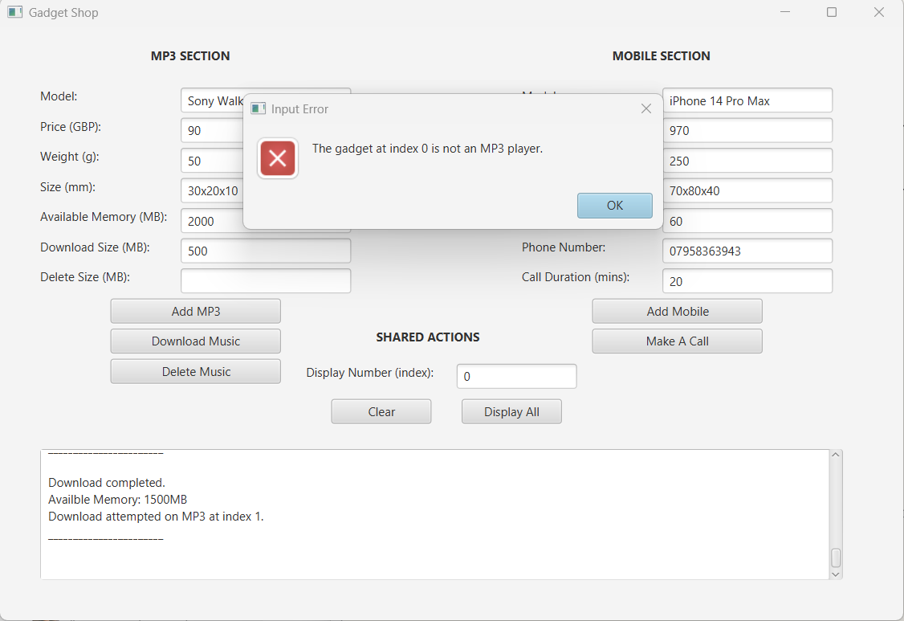
Test 7 – Deleting Music from MP3
Input:
- Model: Sony Walkman 2013
- Price: 90
- Weight: 50
- Size: 30x20x10
- Memory: 2000
- Delete Size: 500 MB
Expected Result: The selected MP3 player should have the specified music size removed, and the available memory should increase accordingly. The system should then display a confirmation message together with the updated available memory in the log area
MP3 available memory increases successfully.
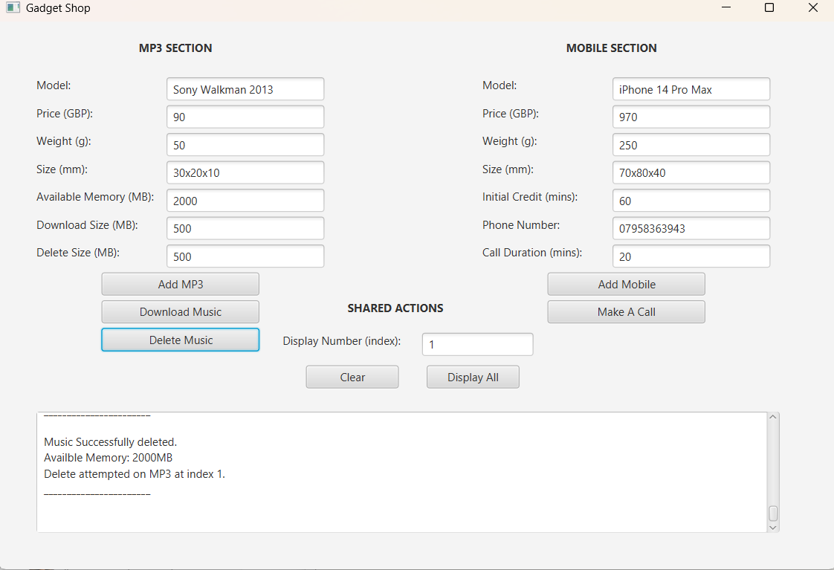

11. Running Program in Command Prompt
The program was compiled and run with the command prompt.
Compilation: javac .java
Execution: java GadgetShop
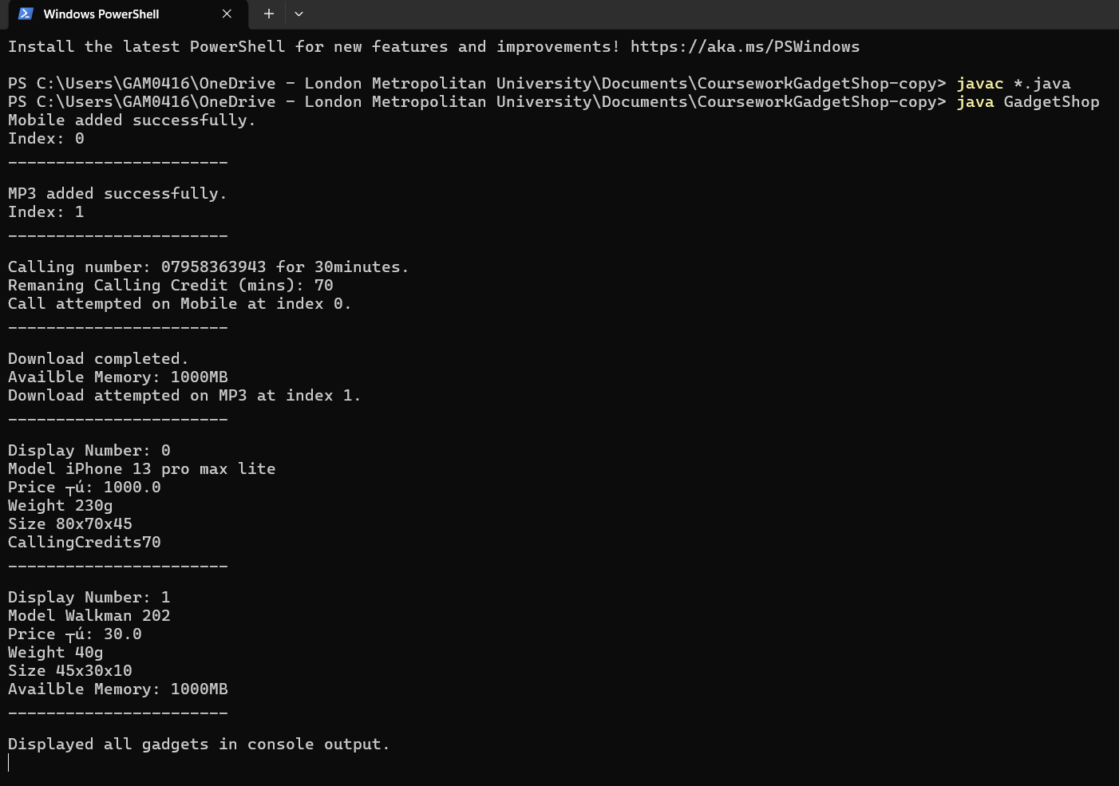
Fig 14
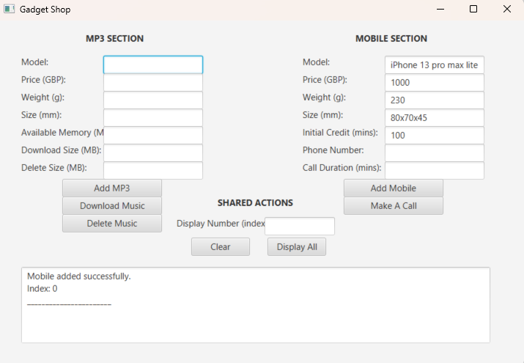
Fig 15
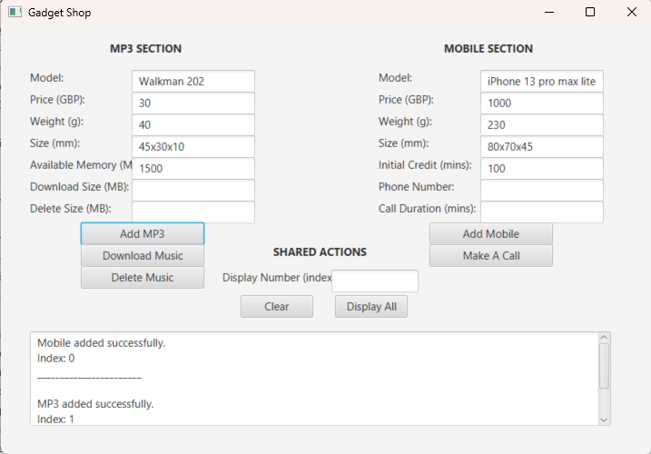
Fig 16
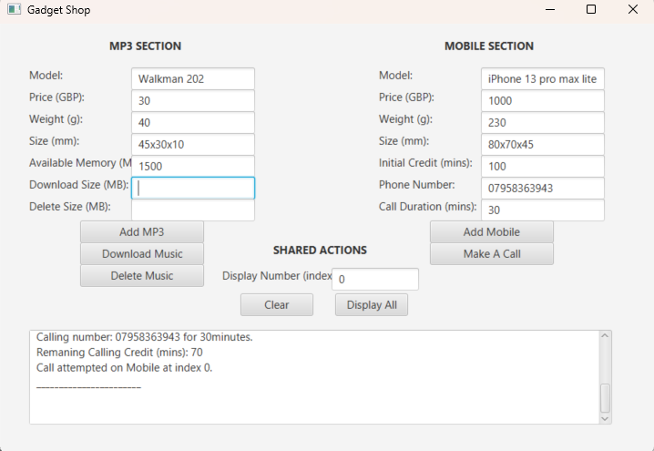
Fig 17
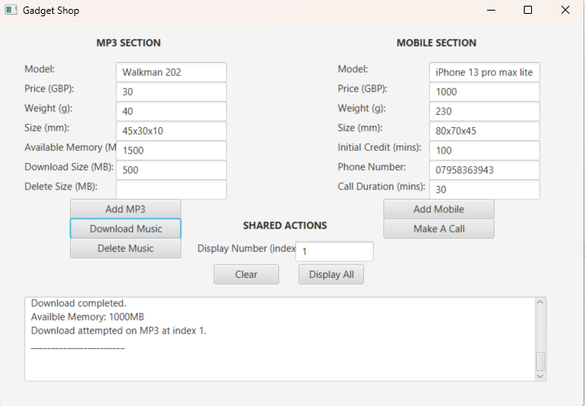
Fig 18

12. Error Detection and Correction
Error handling techniques such as exception handling and input validation are essential in software development to improve system robustness and prevent unexpected crashes [3].
Several errors were encountered while the program was being developed.
Error 1 – Incorrect Data Type for Phone Number
Error: Initially, the phone number was implemented using an integer data type. This caused issues because UK phone numbers may include leading zeros or symbols such as “+44”, which cannot be represented as integers. Error was detected by inserting an “o” instead of Zero “0”.
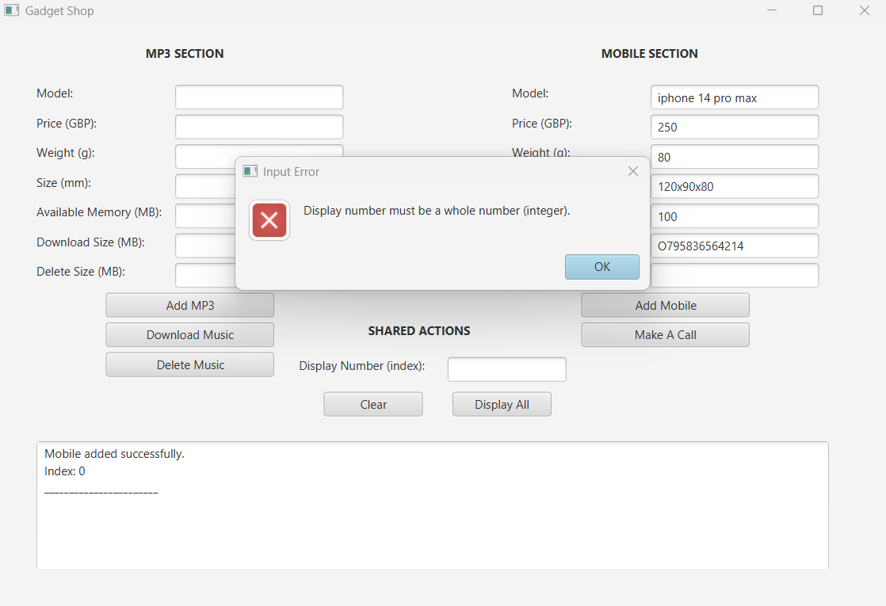

Solution: The phone number was changed to a String data type. This allows the system to correctly handle all valid UK phone number formats without data loss or errors.
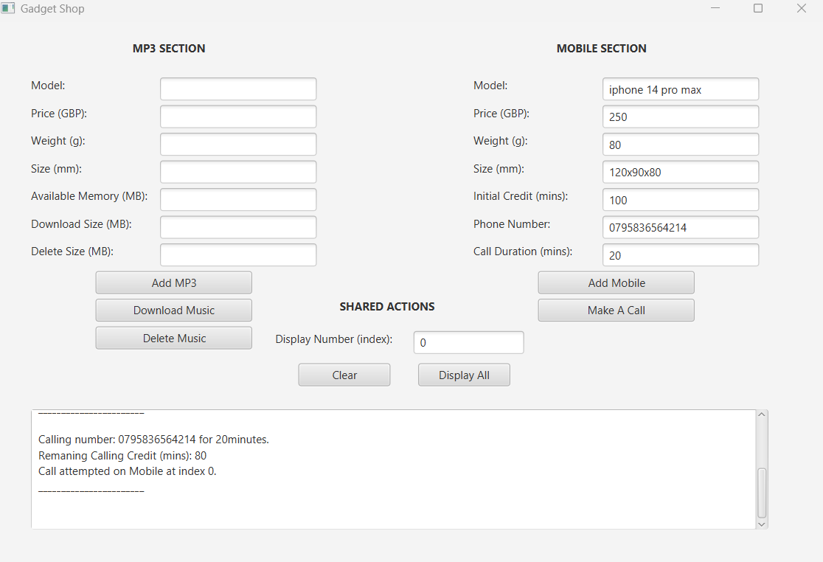
Error 2 – MP3 Memory Download Logic error (initial design)
Error: I discovered that there is a logic error in the downloadMusic() method, as an additional 3G SD card memory is added automatically even when the MP3 have enough available memory.
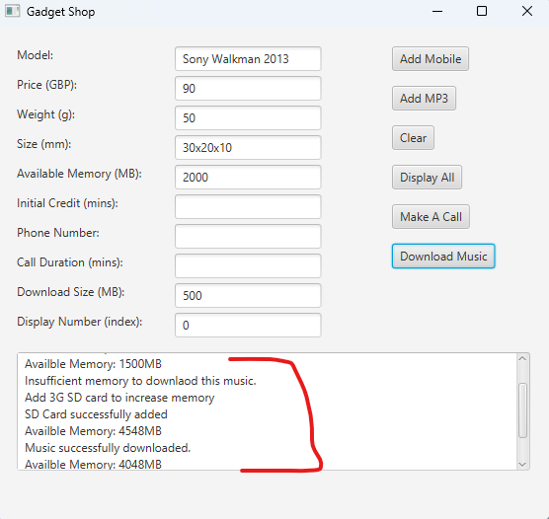
Solution (initial design): I corrected this by ensuring that the 3G SD card is an expansion code to only run inside the ‘else’ block, which means that it will only be triggered only when the music download size is greater than the available memory.
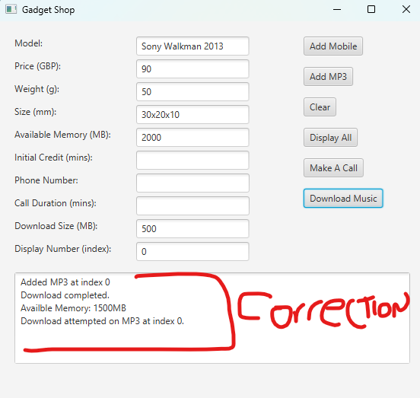

13. Additional Features Addition
Automatic 3GB SD Card Expansion
If MP3 devices have insufficient memory, this system automatically simulates inserting a 3GB SD card.
Example output: “Not enough memory to download this music. Add 3G SD card to increase memory SD card added successfully.
New Available Memory: 4548 MB
Music downloaded successfully after adding SD card.
Remaining Memory: 2458 MB”
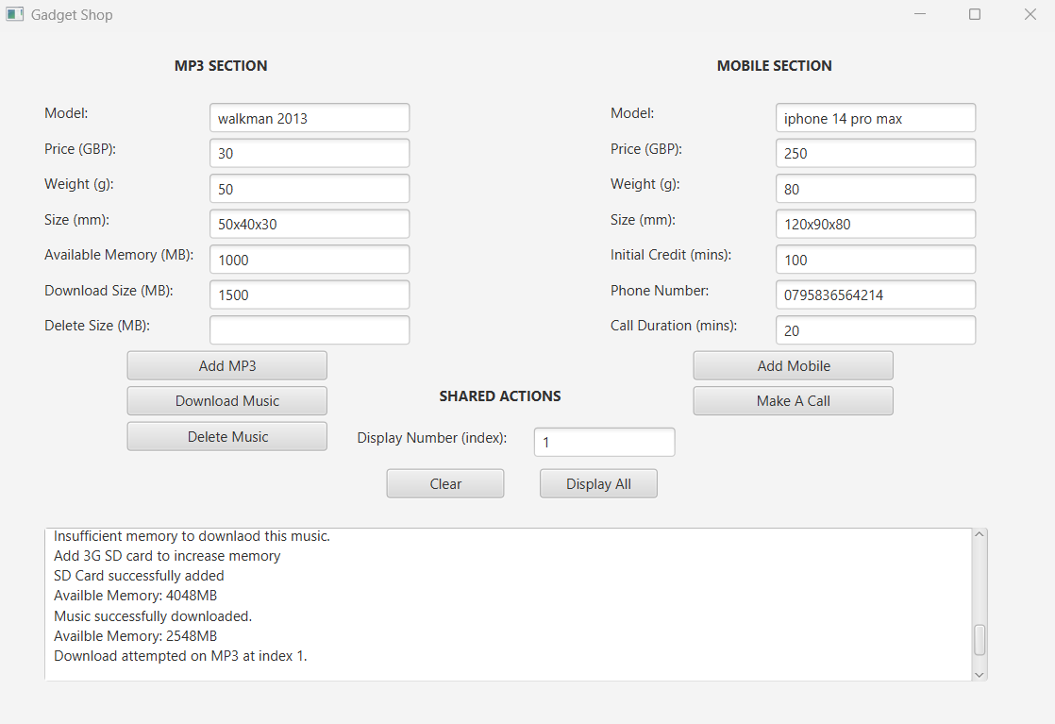
This aspect enhances realism and also shows additional logic.

14. Conclusion
All components of Gadget Shop System with Java and JavaFX were implemented effectively [2]. This application showcases the concepts of inheritance, polymorphism and encapsulation in object-oriented programming [1], [10]. I learned about GUI design, object-oriented design, debugging techniques and error handling, all of which are involved in this kind of work [3], [5]. Databases and new gadget types are possible enhancements to come. I have learned quite a bit about the concept behind object-oriented programming, as well as practical principles behind building reliable and user-friendly applications in this project as a whole [4].

15. References
[[1] D. J. Barnes and M. Kölling, Objects First with Java: A Practical Introduction Using BlueJ, 6th ed. Harlow, UK: Pearson, 2016.
[2] Oracle, “JavaFX Documentation,” [Online]. Available: https://openjfx.io. [Accessed: Apr. 16, 2026].
[3] P. Deitel and H. Deitel, Java: How to Program, 11th ed. Pearson, 2018.
[4] I. Sommerville, Software Engineering, 10th ed. Pearson, 2016.
[5] R. S. Pressman, Software Engineering: A Practitioner’s Approach, 8th ed. McGraw-Hill, 2015.
[6] M. Fowler, UML Distilled: A Brief Guide to the Standard Object Modeling Language, 3rd ed. Addison-Wesley, 2004.
[7] S. Chacon and B. Straub, Pro Git, 2nd ed. Apress, 2014.
[8] Oracle, “Java Documentation,” [Online]. Available: https://docs.oracle.com. [Accessed: Apr. 16, 2026].
[9] E. Gamma et al., Design Patterns: Elements of Reusable Object-Oriented Software. Addison-Wesley, 1994.
[10] H. M. Deitel and P. J. Deitel, Java: Object-Oriented Programming. Pearson, 2017.

16. Appendix
Full source code included in this order:

Appendix A – Gadget
/**
* Write a description of class Gadget here.
*
* Author -Gadaf Malik-Abbas
* Student ID - 25000098
*/
public class Gadget
{
// these are the instance variables (attributes) that define a Gadget object
private String model;
private double price;
private int weight;
private String size;
public Gadget(String model, double price, int weight, String size)
{
// this constructor is used to initialise the object when it is created

/**
* Constructor for Class Gadget
* this is where the object gets its starting values from the user input
* it basically assigns the parameters into the class variables using encapsulation
* price - in £ (GBP)
* Weight - in g (Gram)
* Size - in mm (milemeter)
*/
this.model=model;
this.price=price;
this.weight=weight;
this.size=size;
}
//this is an accessor (getter) method to return the model of the Gadget object
public String getModel()
{
return model;
}
//this is an accessor (getter) method to return the weight of the Gadget object
public int getWeight()
{
return weight;
}

//this is an accessor (getter) method to return the size of the Gadget object
public String getSize()
{
return size;
}
// this is a general method used to display the Gadget details to the user
public void display()
{
// this prints out all the main attributes of the object
System.out.println("Model " + model);
System.out.println("Price £: "+ price);
System.out.println("Weight "+ weight + "g");
System.out.println("Size " + size);
}
}

Appendix B – Mobile
/**
* Write a description of class Mobile here.
*
* Author -Gadaf Malik-Abbas
* Student ID - 25000098
*/
public class Mobile extends Gadget
{
// this instance variable is used to store the amount of minutes left for this Mobile object (calling credit)
private int callingCredits;
/**
* Constructor for class mobile
* this constructor accepts 5 parameters and uses inheritance to pass 4 of them
* into the Gadget superclass using super()
* price - in £ (GBP)
* Weight - in g (Gram)
* Size - in mm (milemeter)
*/
public Mobile(String model, double price, int weight, String size, int callingCredits)
{
// this calls the superclass constructor so the shared attributes are initialised for this object
super(model,price,weight,size);
this.callingCredits=callingCredits;

}
// this is an accessor (getter) method to return the current calling credit of the Mobile object
public int getCallingCredits()
{
return callingCredits;
}

//this method enables the user to load calling credit onto the Mobile object
public void addCallingCredit(int credit)
// validation check (only allow positive credit values to be added)
{
if (credit > 0)
{
callingCredits = callingCredits +credit;
}
else
{
System.out.println("Please load a positive amount of calling credit");
}
}

public void makeCall(String number, int duration)
{
// validation check, duration must be greater than zero before continuing
if (duration <=0)
{
System.out.println("Please enter a calling duration greater than zero");
return;
}
// this condition checks if the Mobile object has enough credit to make the call
if (callingCredits >= duration)
{
//display message showing phone number and duration of the call
System.out.println("Calling number: " + number + " for " + duration +"minutes.");

//this reduces the credit from the object after the call is made
callingCredits = callingCredits-duration;

// display remaining credit (balance) after each call
System.out.println("Remaning Calling Credit (mins): " + callingCredits);
}

else
//display message if the object does not have enough credit
{
System.out.println("Insufficient calling credit to initiate this call. please load more credit.");
System.out.println("Current Calling Credit (mins): " + callingCredits);
}
}
//method to display all the Mobile object details
public void display()
{
//display the inherited gadget details first using polymorphism (method overriding)
super.display();
//display the Mobile specific attribute which is the calling credit
System.out.println("CallingCredits" + callingCredits);
}
}
}

Appendix C – MP3
/**
* Write a description of class MP3 here.
*
* Author -Gadaf Malik-Abbas
* Student ID - 25000098
*/
public class MP3 extends Gadget
{
// this instance variable is to store the avialable memory for the MP3 object
private int availableMemory;
/**
* Constructor for objects of class MP3
* this constructor accepts 5 parameters and uses inheritance to pass the
* common values into the Gadget superclass constructor
* price - in £ (GBP)
* Weight - in g (Gram)
* Size - in mm (milemeter)
*/
public MP3(String model, double price, int weight, String size, int availableMemory)
{
// this line calls the Gadget constructor so the shared attributes of the object can be initialised properlly
super(model, price,weight,size);
this.availableMemory=availableMemory;
}

//this is the accessor method (getter) used to return the avaiable memory of this MP3 object
public int getAvailableMemory()
{
return availableMemory;
}
//this is the method to enable the user to download music into the MP3 player object
public void downloadMusic(int downloadSize)
{
if (downloadSize <=0)
{ //this is the validation part to check the download size is greater than zero before the method continues
System.out.println("Please enter a download size greater than zero");
return;
}
//this condition checks the current available memory left in the MP3 object instance
else if (availableMemory >= downloadSize)
{
//this line reduces the available memory after the download has completed
availableMemory = availableMemory - downloadSize;
//this displays a confirmation message and then shows the updated memory left
System.out.println("Download completed.");
System.out.println("Availble Memory: " + availableMemory +"MB");
}
else
{
//this part displays an error style message if there is not enough memory in the object
System.out.println("Insufficient memory to downlaod this music.");
System.out.println("Add 3G SD card to increase memory");
//this line increases the memory by adding a 3G SD card automaticly
availableMemory = availableMemory +3048;
System.out.println("SD Card successfully added");
System.out.println("Availble Memory: " + availableMemory +"MB");
//this is the logic to try the download again after the extra memory has been added
if (availableMemory >= downloadSize)
{
availableMemory = availableMemory - downloadSize;
System.out.println("Music successfully downloaded.");
System.out.println("Availble Memory: " + availableMemory +"MB");
}
}
}
// This method allows the user to delete music from the MP3 object
public void deleteMusic(int deleteSize)
{
//this validation checks that the delete size entered is greater than zero
if (deleteSize <=0)
{
System.out.println("Enter a delete size greater than zero.");
return;
}
//this line restores memory back to the object once the music has been deleted
availableMemory=availableMemory+deleteSize;
//this displays a delete confirmation and then the current available memory
System.out.println("Music Successfully deleted.");
System.out.println("Availble Memory: " + availableMemory +"MB");
}

//Method to display details of MP3 player by overriding the display method from the superclass
public void display()
{
super.display();
//this line displays the MP3 specific attribute which is the available memory
System.out.println("Availble Memory: " + availableMemory +"MB");
}
}

Appendix D – GadgetShop
/**
* Write a description of class GadgetShop here.
*
* Author -Gadaf Malik-Abbas
* Student ID - 25000098
*/
import javafx.application.Application;
import javafx.application.Platform;
import javafx.scene.Scene;
import javafx.scene.control.*;
import javafx.scene.layout.Pane;
import javafx.stage.Stage;
import java.io.OutputStream;
import java.io.PrintStream;
import java.util.ArrayList;

public class GadgetShop extends Application {
// text field used to capture the Mobile model name
private final TextField mobileModelField = new TextField();
// text field used to capture the Mobile price
private final TextField mobilePriceField = new TextField();
// text field used to capture the Mobile weight
private final TextField mobileWeightField = new TextField();
// text field used to capture the Mobile size
private final TextField mobileSizeField = new TextField();

// text field used to capture the MP3 model name
private final TextField mp3ModelField = new TextField();
// text field used to capture the MP3 price
private final TextField mp3PriceField = new TextField();
// text field used to capture the MP3 weight
private final TextField mp3WeightField = new TextField();
// text field used to capture the MP3 size
private final TextField mp3SizeField = new TextField();

// text field used to capture MP3 available memory
private final TextField availableMemoryField = new TextField();
// text area used to show system output and user feed back in real time
private final TextArea logArea = new TextArea();
// text field used to capture initial mobile credit
private final TextField creditField = new TextField();
// text field used to capture phone number for a call
private final TextField phoneNumberField = new TextField();
// text field used to capture call duration
private final TextField durationField = new TextField();
// text field used to capture MP3 download size
private final TextField downloadSizeField = new TextField();
// text field used to capture MP3 delete size
private final TextField deleteSizeField = new TextField();
// text field used to capture display number for selecting an object instance
private final TextField displayNumberField = new TextField();
private final ArrayList<Gadget> gadgets = new ArrayList<>();

@Override
public void start(Stage stage) {
Pane root = new Pane();

Label mp3SectionLabel = new Label("MP3 SECTION");
mp3SectionLabel.setLayoutX(150);
mp3SectionLabel.setLayoutY(20);
mp3SectionLabel.setStyle("-fx-font-weight: bold;");

Label mobileSectionLabel = new Label("MOBILE SECTION");
mobileSectionLabel.setLayoutX(610);
mobileSectionLabel.setLayoutY(20);
mobileSectionLabel.setStyle("-fx-font-weight: bold;");

Label sharedSectionLabel = new Label("SHARED ACTIONS");
sharedSectionLabel.setLayoutX(375);
sharedSectionLabel.setLayoutY(300);
sharedSectionLabel.setStyle("-fx-font-weight: bold;");

// label and text field for MP3 model input
Label mp3ModelLabel = new Label("Model:");
mp3ModelLabel.setLayoutX(40);
mp3ModelLabel.setLayoutY(60);

mp3ModelField.setLayoutX(180);
mp3ModelField.setLayoutY(60);
mp3ModelField.setPrefWidth(170);

// label and text field for MP3 price input
Label mp3PriceLabel = new Label("Price (GBP):");
mp3PriceLabel.setLayoutX(40);
mp3PriceLabel.setLayoutY(90);

mp3PriceField.setLayoutX(180);
mp3PriceField.setLayoutY(90);
mp3PriceField.setPrefWidth(170);

// label and text field for MP3 weight input
Label mp3WeightLabel = new Label("Weight (g):");
mp3WeightLabel.setLayoutX(40);
mp3WeightLabel.setLayoutY(120);

mp3WeightField.setLayoutX(180);
mp3WeightField.setLayoutY(120);
mp3WeightField.setPrefWidth(170);

// label and text field for MP3 size input
Label mp3SizeLabel = new Label("Size (mm):");
mp3SizeLabel.setLayoutX(40);
mp3SizeLabel.setLayoutY(150);

mp3SizeField.setLayoutX(180);
mp3SizeField.setLayoutY(150);
mp3SizeField.setPrefWidth(170);

// label and text field for MP3 available memory input
Label availableMemoryLabel = new Label("Available Memory (MB):");
availableMemoryLabel.setLayoutX(40);
availableMemoryLabel.setLayoutY(180);

availableMemoryField.setLayoutX(180);
availableMemoryField.setLayoutY(180);
availableMemoryField.setPrefWidth(170);

// label and text field for music download size entry
Label downloadLabel = new Label("Download Size (MB):");
downloadLabel.setLayoutX(40);
downloadLabel.setLayoutY(210);

downloadSizeField.setLayoutX(180);
downloadSizeField.setLayoutY(210);
downloadSizeField.setPrefWidth(170);

// label and text field for music delete size entry
Label deleteLabel = new Label("Delete Size (MB):");
deleteLabel.setLayoutX(40);
deleteLabel.setLayoutY(240);

deleteSizeField.setLayoutX(180);
deleteSizeField.setLayoutY(240);
deleteSizeField.setPrefWidth(170);

// button used to create and add a new MP3 object
Button addMP3Button = new Button("Add MP3");
addMP3Button.setLayoutX(110);
addMP3Button.setLayoutY(270);
addMP3Button.setPrefWidth(170);

// button used to run the downloadMusic behaviour on an MP3 object
Button downloadMusicButton = new Button("Download Music");
downloadMusicButton.setLayoutX(110);
downloadMusicButton.setLayoutY(300);
downloadMusicButton.setPrefWidth(170);

// button used to run the deleteMusic behaviour on an MP3 object
Button deleteMusicButton = new Button("Delete Music");
deleteMusicButton.setLayoutX(110);
deleteMusicButton.setLayoutY(330);
deleteMusicButton.setPrefWidth(170);

// label and text field for Mobile model input
Label mobileModelLabel = new Label("Model:");
mobileModelLabel.setLayoutX(520);
mobileModelLabel.setLayoutY(60);

mobileModelField.setLayoutX(660);
mobileModelField.setLayoutY(60);
mobileModelField.setPrefWidth(170);

// label and text field for Mobile price input
Label mobilePriceLabel = new Label("Price (GBP):");
mobilePriceLabel.setLayoutX(520);
mobilePriceLabel.setLayoutY(90);

mobilePriceField.setLayoutX(660);
mobilePriceField.setLayoutY(90);
mobilePriceField.setPrefWidth(170);

// label and text field for Mobile weight input
Label mobileWeightLabel = new Label("Weight (g):");
mobileWeightLabel.setLayoutX(520);
mobileWeightLabel.setLayoutY(120);

mobileWeightField.setLayoutX(660);
mobileWeightField.setLayoutY(120);
mobileWeightField.setPrefWidth(170);

// label and text field for Mobile size input
Label mobileSizeLabel = new Label("Size (mm):");
mobileSizeLabel.setLayoutX(520);
mobileSizeLabel.setLayoutY(150);

mobileSizeField.setLayoutX(660);
mobileSizeField.setLayoutY(150);
mobileSizeField.setPrefWidth(170);

// label and text field for initial calling credit entry
Label creditLabel = new Label("Initial Credit (mins):");
creditLabel.setLayoutX(520);
creditLabel.setLayoutY(180);

creditField.setLayoutX(660);
creditField.setLayoutY(180);
creditField.setPrefWidth(170);

// label and text field for phone number entry, stored as String to fit UK format
Label phoneLabel = new Label("Phone Number:");
phoneLabel.setLayoutX(520);
phoneLabel.setLayoutY(210);

phoneNumberField.setLayoutX(660);
phoneNumberField.setLayoutY(210);
phoneNumberField.setPrefWidth(170);

// label and text field for call duration entry
Label durationLabel = new Label("Call Duration (mins):");
durationLabel.setLayoutX(520);
durationLabel.setLayoutY(240);

durationField.setLayoutX(660);
durationField.setLayoutY(240);
durationField.setPrefWidth(170);

// button used to create and add a new Mobile object
Button addMobileButton = new Button("Add Mobile");
addMobileButton.setLayoutX(590);
addMobileButton.setLayoutY(270);
addMobileButton.setPrefWidth(170);

// button used to run the makeCall behaviour on a Mobile object
Button makeCallButton = new Button("Make A Call");
makeCallButton.setLayoutX(590);
makeCallButton.setLayoutY(300);
makeCallButton.setPrefWidth(170);

// label and text field for display number, this is used to select the right object instance
Label displayNumberLabel = new Label("Display Number (index):");
displayNumberLabel.setLayoutX(305);
displayNumberLabel.setLayoutY(335);

displayNumberField.setLayoutX(455);
displayNumberField.setLayoutY(335);
displayNumberField.setPrefWidth(120);

// button used to clear all current user entries
Button clearButton = new Button("Clear");
clearButton.setLayoutX(330);
clearButton.setLayoutY(370);
clearButton.setPrefWidth(100);

// button used to display all object instances stored in the ArrayList
Button displayAllButton = new Button("Display All");
displayAllButton.setLayoutX(460);
displayAllButton.setLayoutY(370);
displayAllButton.setPrefWidth(100);

// log area setup, this is where system responses and display output will show
logArea.setLayoutX(40);
logArea.setLayoutY(420);
logArea.setPrefWidth(800);
logArea.setPrefHeight(130);
logArea.setEditable(false);

// this method redirects System.out.println to both the logArea and command prompt
PrintStream consoleOutput = System.out;

System.setOut(new PrintStream(new OutputStream()
{
@Override
public void write(int b)
{
// method to send output to command prompt as normal
consoleOutput.write(b);

// method send output to the text area so the user can see feed back live
Platform.runLater(() ->
logArea.appendText(String.valueOf((char) b))
);
}
}));

// this is to add the Add Mobile button
addMobileButton.setOnAction(e ->
{
String model = getMobileModel();
String size = getMobileSize();
double price = getMobilePrice();
int weight = getMobileWeight();
int credit = getCredit();

// this validation is to make sure the basic text input is not empty before creating the object
if (model.isEmpty() || size.isEmpty())
{
showError("Please enter a valid model and size.");
return;
}

Mobile m = new Mobile(model, price, weight, size, credit);
gadgets.add(m);
log("Mobile added successfully.");
log("Index: " + (gadgets.size() - 1));
logDivider();
});

// this is to add the Add MP3 button
addMP3Button.setOnAction(e ->
{
String model = getMP3Model();
String size = getMP3Size();
double price = getMP3Price();
int weight = getMP3Weight();
int memory = getAvailableMemory();

// simple validation to stop empty values before creating the object
if (model.isEmpty() || size.isEmpty())
{
showError("Please insert a valid model and size.");
return;
}

MP3 mp3 = new MP3(model, price, weight, size, memory);
gadgets.add(mp3);
log("MP3 added successfully.");
log("Index: " + (gadgets.size() - 1));
logDivider();
});

// this is to Clear all 10 text fields/button
clearButton.setOnAction(e ->
{
mobileModelField.clear();
mobilePriceField.clear();
mobileWeightField.clear();
mobileSizeField.clear();
mp3ModelField.clear();
mp3PriceField.clear();
mp3WeightField.clear();
mp3SizeField.clear();
creditField.clear();
availableMemoryField.clear();
phoneNumberField.clear();
durationField.clear();
downloadSizeField.clear();
deleteSizeField.clear();
displayNumberField.clear();

log("All fields cleared.");
logDivider();
});

// this is to Display All button on the GUI interface
displayAllButton.setOnAction(e ->
{
if (gadgets.isEmpty())
{
log("No gadgets are available to display.");
return;
}

for (int i = 0; i < gadgets.size(); i++)
{
log("Display Number: " + i);
gadgets.get(i).display();
logDivider();
}

log("Displayed all gadgets in console output.");
});

// this method for Make A Call button to esure index number and displayed number is validated before proceeding
makeCallButton.setOnAction(e ->
{
int displayNumber = getDisplayNumber();
if (displayNumber == -1)
{
return;
}

Gadget g = gadgets.get(displayNumber);
// this method is to check and ensure the selected object is really a Mobile instance before makeCall is used
if (g instanceof Mobile)
{
// phone number in string (to match UK phone numbers format 07400 or +44)
String phoneNumber = getPhoneNumber();
int duration = getDuration();
((Mobile) g).makeCall(phoneNumber, duration);
log("Call attempted on Mobile at index " + displayNumber + ".");
logDivider();
}
else
{
showError("The gadget at index " + displayNumber + " is not a Mobile phone.");
}
});
// this method is to show action performed when Download Music button is clicked and also avoid crashing
downloadMusicButton.setOnAction(e ->
{
int displayNumber = getDisplayNumber();
if (displayNumber == -1)
{
return;
}
Gadget g = gadgets.get(displayNumber);
// this method is to ensure safe casting by checking the selected object is an MP3 instance first
if (g instanceof MP3)
{
int downloadSize = getDownloadSize();
((MP3) g).downloadMusic(downloadSize);
log("Download attempted on MP3 at index " + displayNumber + ".");
logDivider();
}
else
{
showError("The gadget at index " + displayNumber + " is not an MP3 player.");
}
});

// this method is to show action performed when Delete Music button is clicked and also avoid crashing
deleteMusicButton.setOnAction(e ->
{
int displayNumber = getDisplayNumber();
if (displayNumber == -1)
{
return;
}
Gadget g = gadgets.get(displayNumber);
// this method is to ensure safe casting by checking the selected object is an MP3 instance first
if (g instanceof MP3)
{
int deleteSize = getDeleteSize();
((MP3) g).deleteMusic(deleteSize);
log("Delete attempted on MP3 at index " + displayNumber + ".");
logDivider();
}
else
{
showError("The gadget at index " + displayNumber + " is not an MP3 player.");
}
});

// All the GUI panes
root.getChildren().addAll(
mp3SectionLabel, mobileSectionLabel, sharedSectionLabel,
mp3ModelLabel, mp3ModelField,
mp3PriceLabel, mp3PriceField,
mp3WeightLabel, mp3WeightField,
mp3SizeLabel, mp3SizeField,
availableMemoryLabel, availableMemoryField,
downloadLabel, downloadSizeField,
deleteLabel, deleteSizeField,
mobileModelLabel, mobileModelField,
mobilePriceLabel, mobilePriceField,
mobileWeightLabel, mobileWeightField,
mobileSizeLabel, mobileSizeField,
creditLabel, creditField,
phoneLabel, phoneNumberField,
durationLabel, durationField,
displayNumberLabel, displayNumberField,
addMobileButton, addMP3Button, clearButton, displayAllButton, makeCallButton, downloadMusicButton, deleteMusicButton,
logArea
);

stage.setScene(new Scene(root, 900, 590));
stage.setTitle("Gadget Shop");
stage.show();
}

// Text Field Input Methods

// accessor style method to return Mobile model as a string
private String getMobileModel()
{
return mobileModelField.getText().trim();
}

// accessor style method to return Mobile size as a string
private String getMobileSize()
{
return mobileSizeField.getText().trim();
}

// accessor style method to return Mobile price as a double
private double getMobilePrice()
{
try
{
return Double.parseDouble(mobilePriceField.getText().trim());
}
catch (Exception e)
{
showError("Price must be a valid number.");
return 0.0;
}
}

// accessor style method to return the Mobile weight as an int (Also show error message)
private int getMobileWeight()
{
try
{
return Integer.parseInt(mobileWeightField.getText().trim());
}
catch (Exception e)
{
showError("Weight must be a whole number.");
return 0;
}
}

// accessor style method to return MP3 model as a string
private String getMP3Model()
{
return mp3ModelField.getText().trim();
}

// accessor style method to return MP3 size as a string
private String getMP3Size()
{
return mp3SizeField.getText().trim();
}

// accessor style method to return MP3 price as a double
private double getMP3Price()
{
try
{
return Double.parseDouble(mp3PriceField.getText().trim());
}
catch (Exception e)
{
showError("Price must be a valid number.");
return 0.0;
}
}

// accessor style method to return the MP3 weight as an int (Also show error message)
private int getMP3Weight()
{
try
{
return Integer.parseInt(mp3WeightField.getText().trim());
}
catch (Exception e)
{
showError("Weight must be a whole number.");
return 0;
}
}

// accessor style method to return initial credit as an int
private int getCredit()
{
try
{
return Integer.parseInt(creditField.getText().trim());
}
catch (Exception e)
{
showError("Initial credit must be a whole number (min).");
return 0;
}
}

// accessor style method to return initial memory as an int
private int getAvailableMemory()
{
try
{
return Integer.parseInt(availableMemoryField.getText().trim());
}
catch (Exception e)
{
showError("Initial memory must be a whole number (MB).");
return 0;
}
}

// accessor style method to return phone number as a string (UK phone number format)
private String getPhoneNumber()
{
return phoneNumberField.getText().trim();
}

// accessor style method to return duration as an int
private int getDuration()
{
try
{
return Integer.parseInt(durationField.getText().trim());
}
catch (Exception e)
{
showError("Call duration must be a whole number (min).");
return 0;
}
}
// accessor style method to return download size as an int
private int getDownloadSize()
{
try
{
return Integer.parseInt(downloadSizeField.getText().trim());
}
catch (Exception e)
{
showError("Download size must be a whole number (MB).");
return 0;
}
}

// accessor style method to return delete size as an int
private int getDeleteSize()
{
try
{
return Integer.parseInt(deleteSizeField.getText().trim());
}
catch (Exception e)
{
showError("Delete size must be a whole number (MB).");
return 0;
}
}

// this method is to display special number
private int getDisplayNumber()
{
// initialise to -1 so invalid input can safely return a fail value
int displayNumber = -1;

try
{
displayNumber = Integer.parseInt(displayNumberField.getText().trim());

// method to check that display number is in the correct range of the ArrayList
if (displayNumber < 0 || displayNumber >= gadgets.size())
{
showError("Display number must be between 0 and " + (gadgets.size() - 1) + ".");
return -1;
}

return displayNumber;
}
catch (Exception e)
{
showError("Display number must be a whole number (integer).");
return -1;
}
}

// helper method to append messages to both the log area and PowerShell
private void log(String message)
{
System.out.println(message);
}

// helper method to add divider and spacing in the log area
private void logDivider()
{
log("_______________________ ");
log("");
}

// helper method to show errors using message dialog box
private void showError(String message)
{
Alert alert = new Alert(Alert.AlertType.ERROR);
alert.setTitle("Input Error");
alert.setHeaderText(null);
alert.setContentText(message);
alert.showAndWait();
}

public static void main(String[] args)
{
launch(args);
}
}

